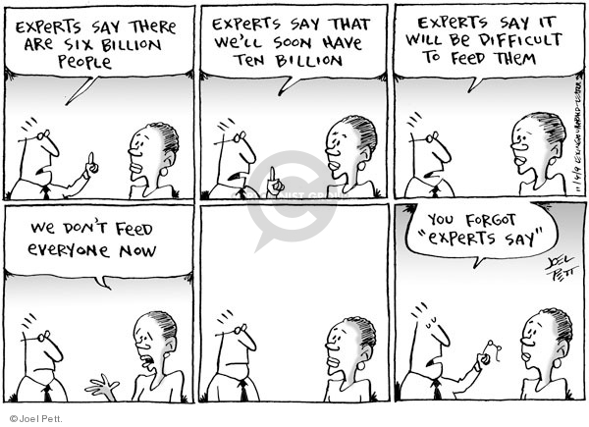**Source 2:**

**http://www.cartoonistgroup.com/subject/The-Production-Comics-and-Cartoons-by-Joel+Pett%27s+Editorial+Cartoons.php**

**Retrieved on 17/8/2017**